# Care and Maintenance of the Microscope

## Introduction

Regular maintenance of your microscope will improve its performance. You should have a professional maintain your microscope each year. In addition, you should clean the base and frame of your microscope by lightly wiping with a damp cloth or wet wipe after each use. Follow the instructions in this job aid regularly to clean the glass parts of your microscope.

Avoid wearing eye makeup when using your microscope — especially mascara. It can leave debris that is hard to remove.

## Supplies

* Commercial lens paper, cotton swabs, or other soft tissue
* Commercially available lens cleaner

## Instructions

1. To determine if your oculars are clean, rotate each one between your fingers to identify debris.
2. Moisten the tip of a swab or a piece of lens paper with lens cleaner.

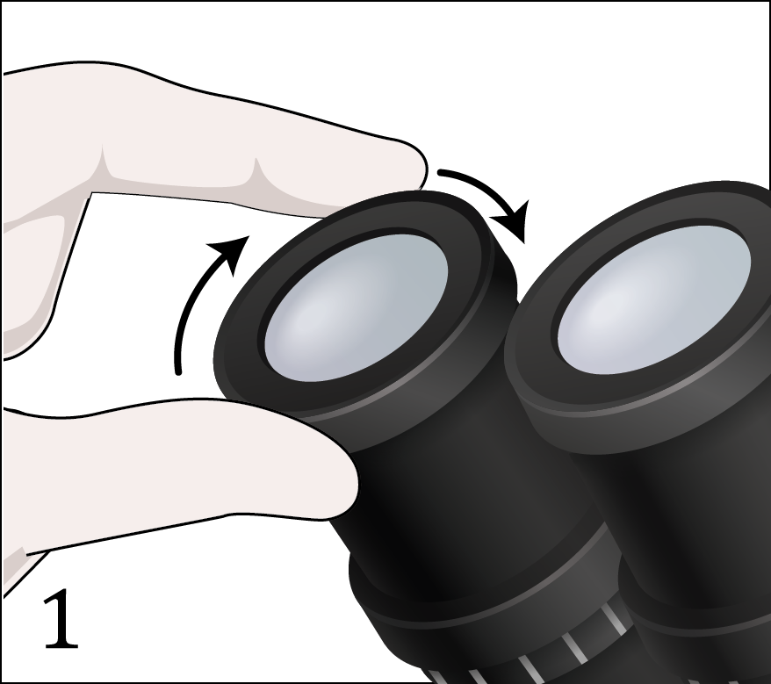 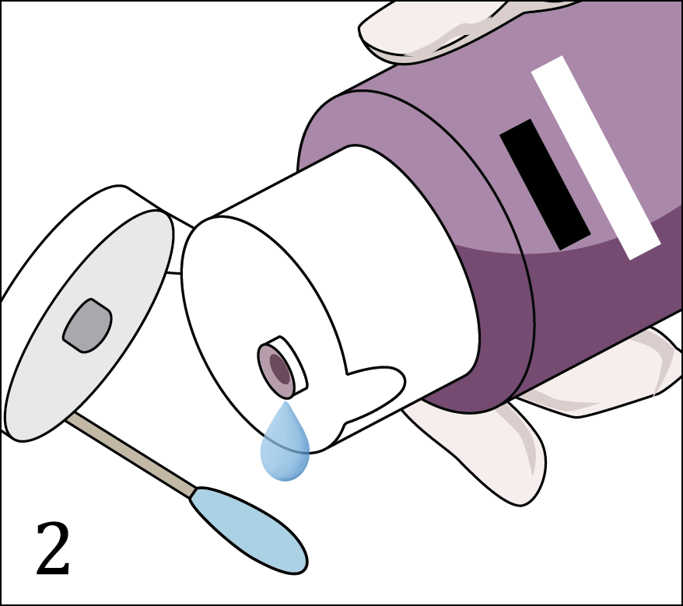

1. Working from the center out, in a circular motion, gently clean the oculars and objectives.
2. Dry with a clean, dry swab or lens paper.

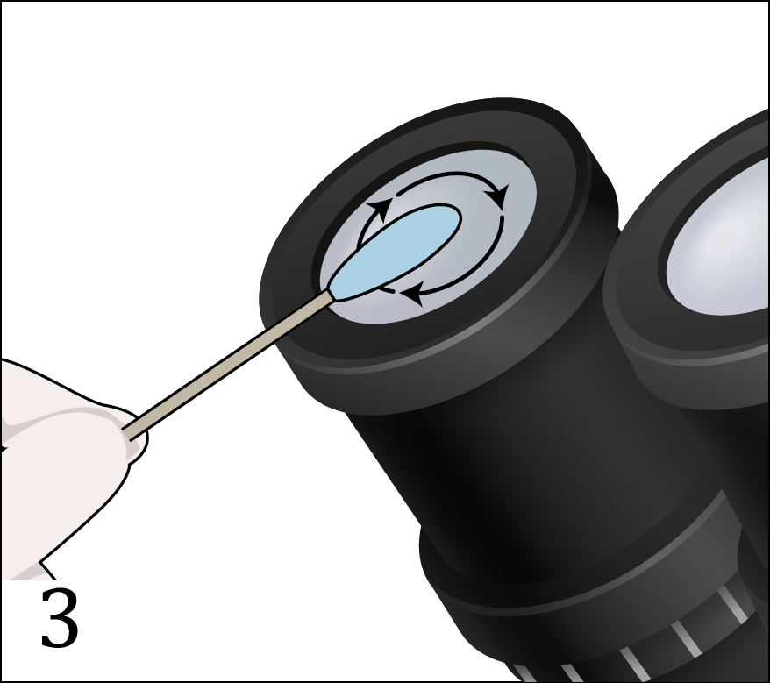 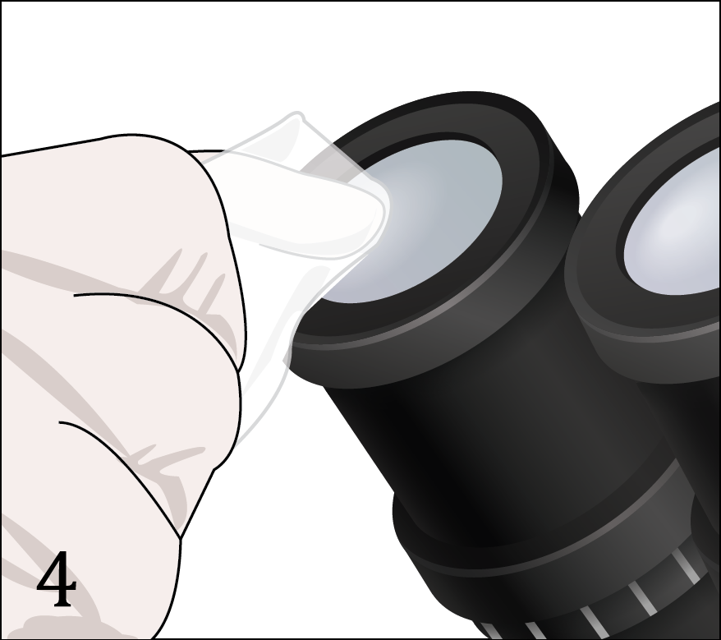

1. Clean the stage of the microscope with a clean lens paper moistened with lens cleaner.
2. Thoroughly dry the stage with a new piece of lens paper.

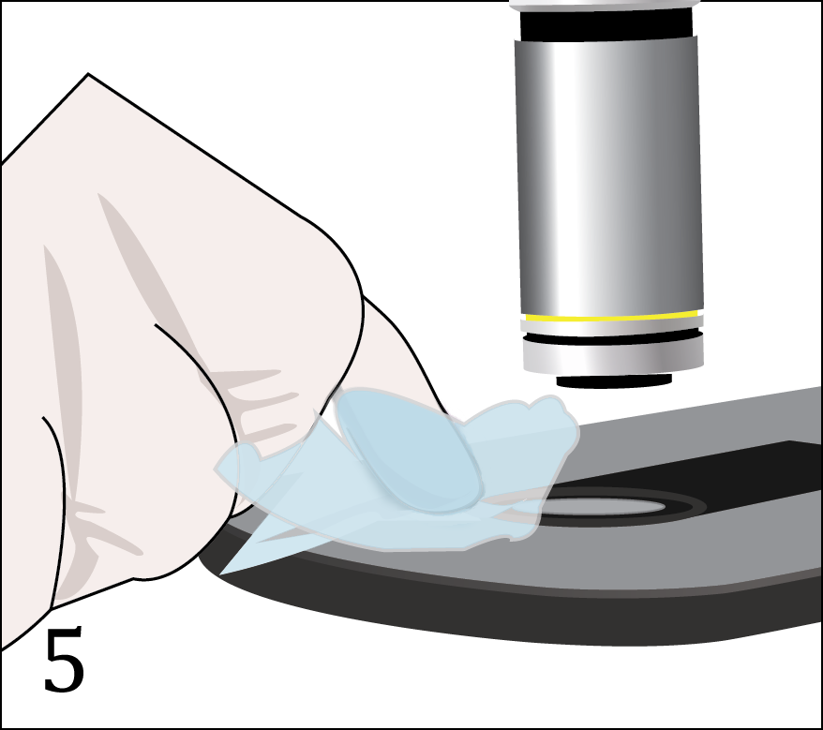 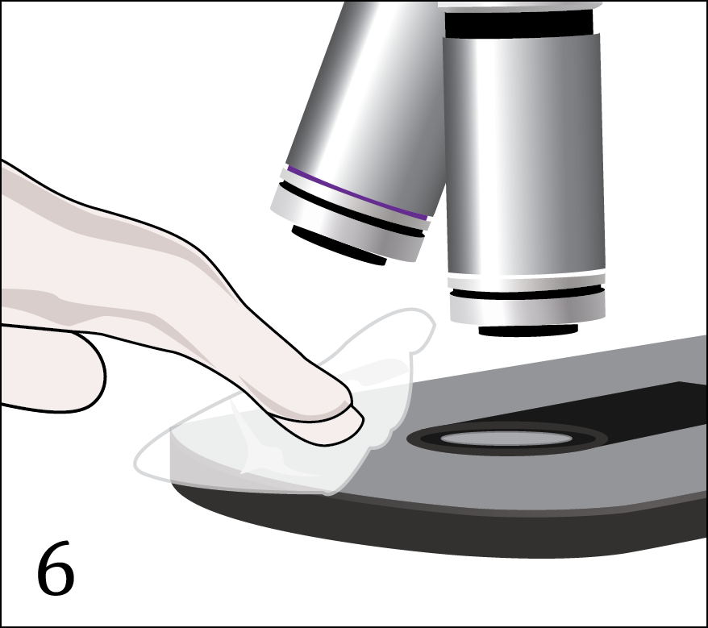

1. Wipe off the top of the condenser with a clean lens paper moistened with lens cleaner.
2. Dry the condenser with a dry piece of lens paper.

