Step 3: Packing Category A, B, and Exempt Animal Specimens Job Aid
Use the pages below as a reference for packing Category A, B, and Exempt Specimens.

Category A Infectious Substance Packaging
NOTE: The packaging is the same for both types (UN 2814 and UN 2900) of Category A packaging, only the UN mark and Proper Shipping Names change. The shipper and consignee address label can be placed on top of the box, if there is not enough space available on one side. UN hazard labels should not overlap one another. For liquid shipments by aircraft, the primary or secondary packaging must be capable of withstanding without leakage an internal pressure producing a pressure differential of not less than 95 kPa.
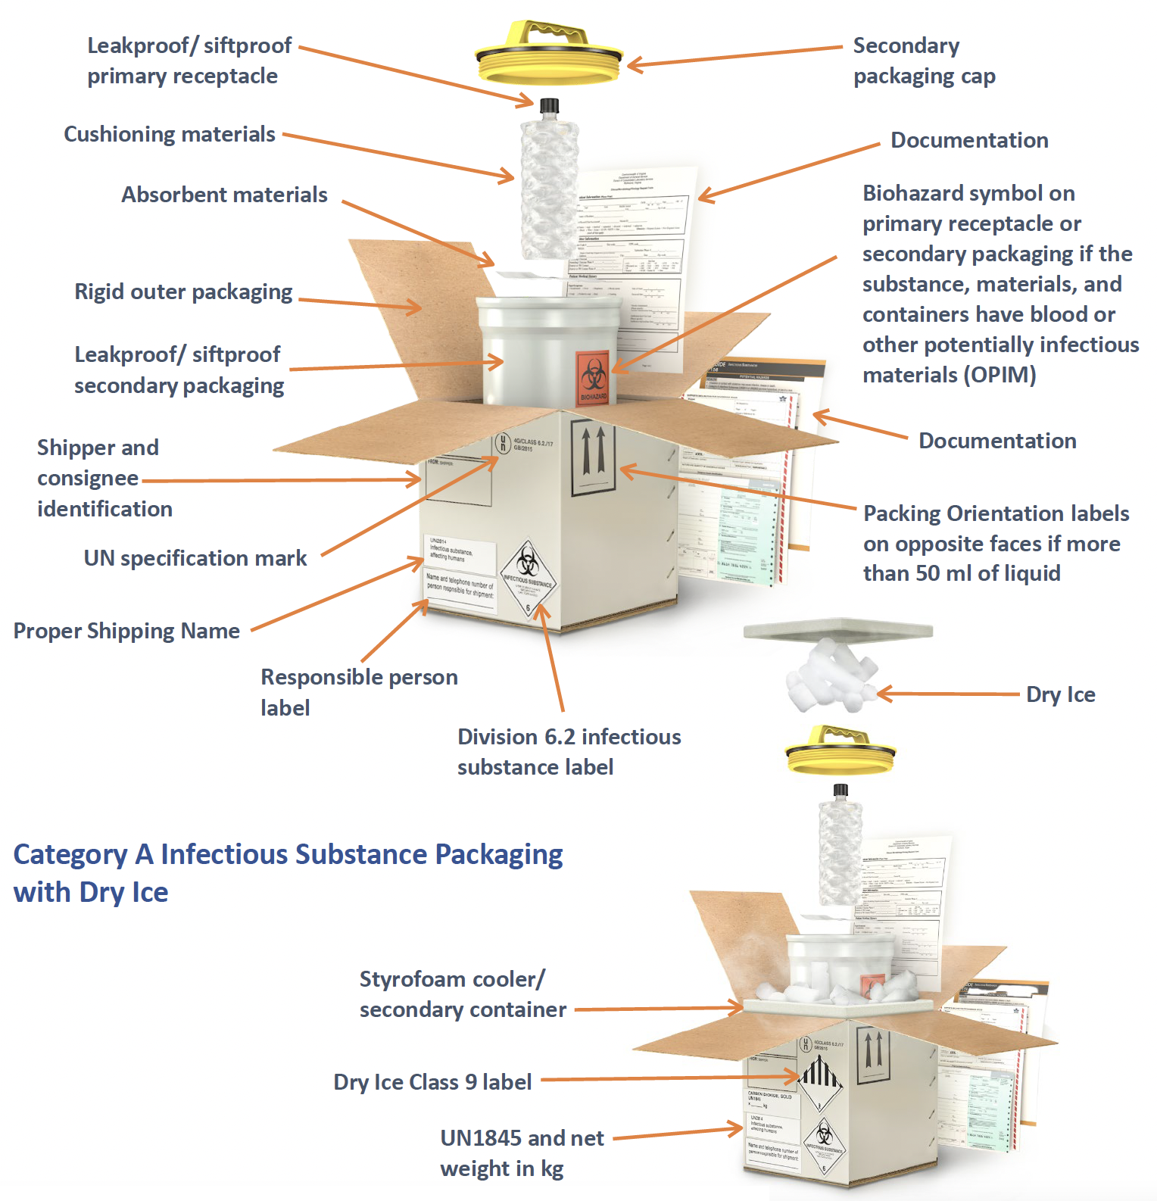

Category B Infectious Substance Packaging
NOTE: The shipper and consignee address label can be placed on top of the box, if there is not enough space available on one side. UN hazard labels should not overlap one another. A cylinder or biobag can be used as the secondary container. For liquid shipments by aircraft, the primary or secondary packaging must be capable of withstanding without leakage an internal pressure producing a pressure differential of not less than 95 kPa.

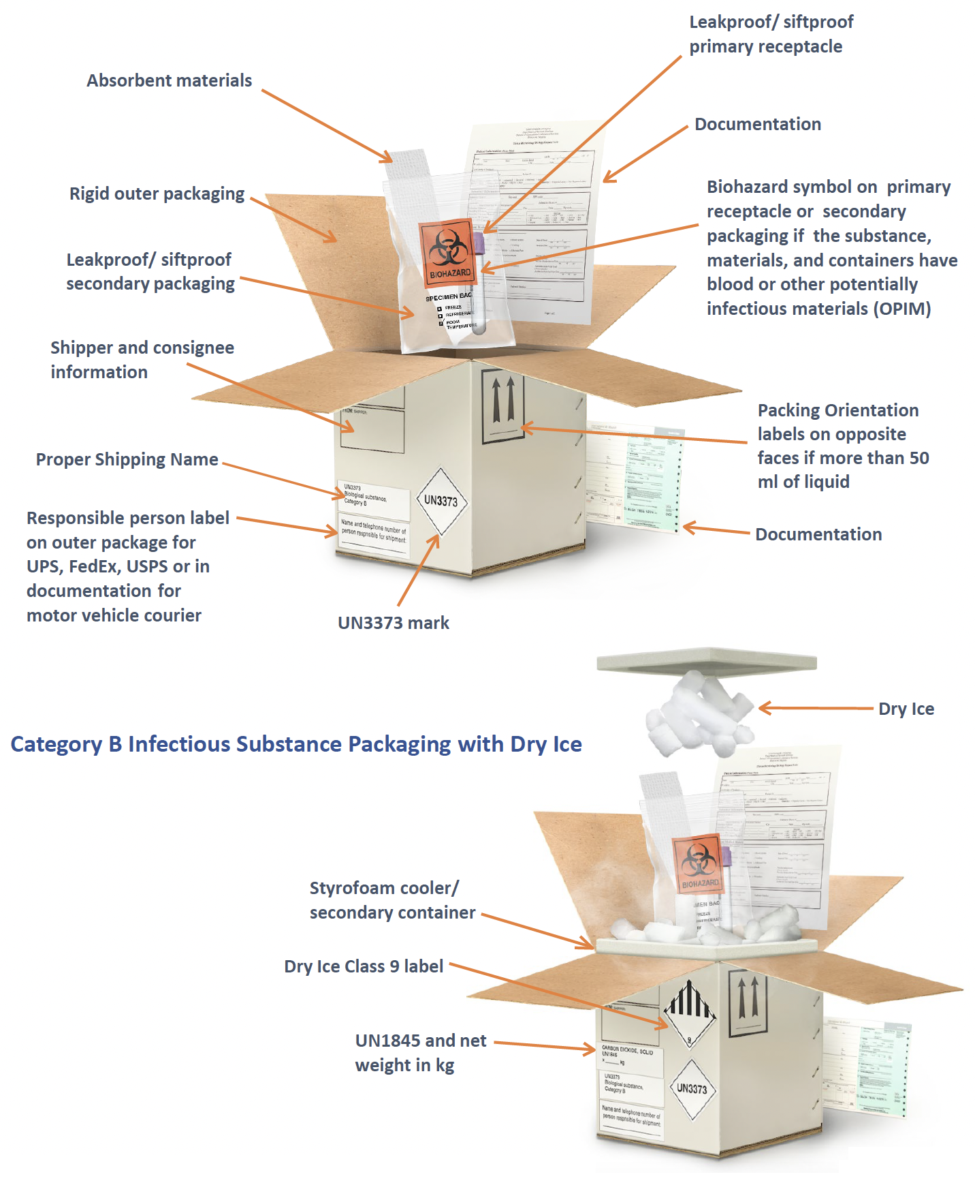
Exempt Human Specimen or Exempt Animal Specimen Packaging
NOTE: The shipper and consignee address label can be placed on top of the box, if there is not enough space available on one side. UN hazard labels should not overlap one another. A cylinder or biobag can be used as the secondary container. For liquid shipments by aircraft, the primary or secondary packaging must be capable of withstanding without leakage an internal pressure producing a pressure differential of not less than 95 kPa.

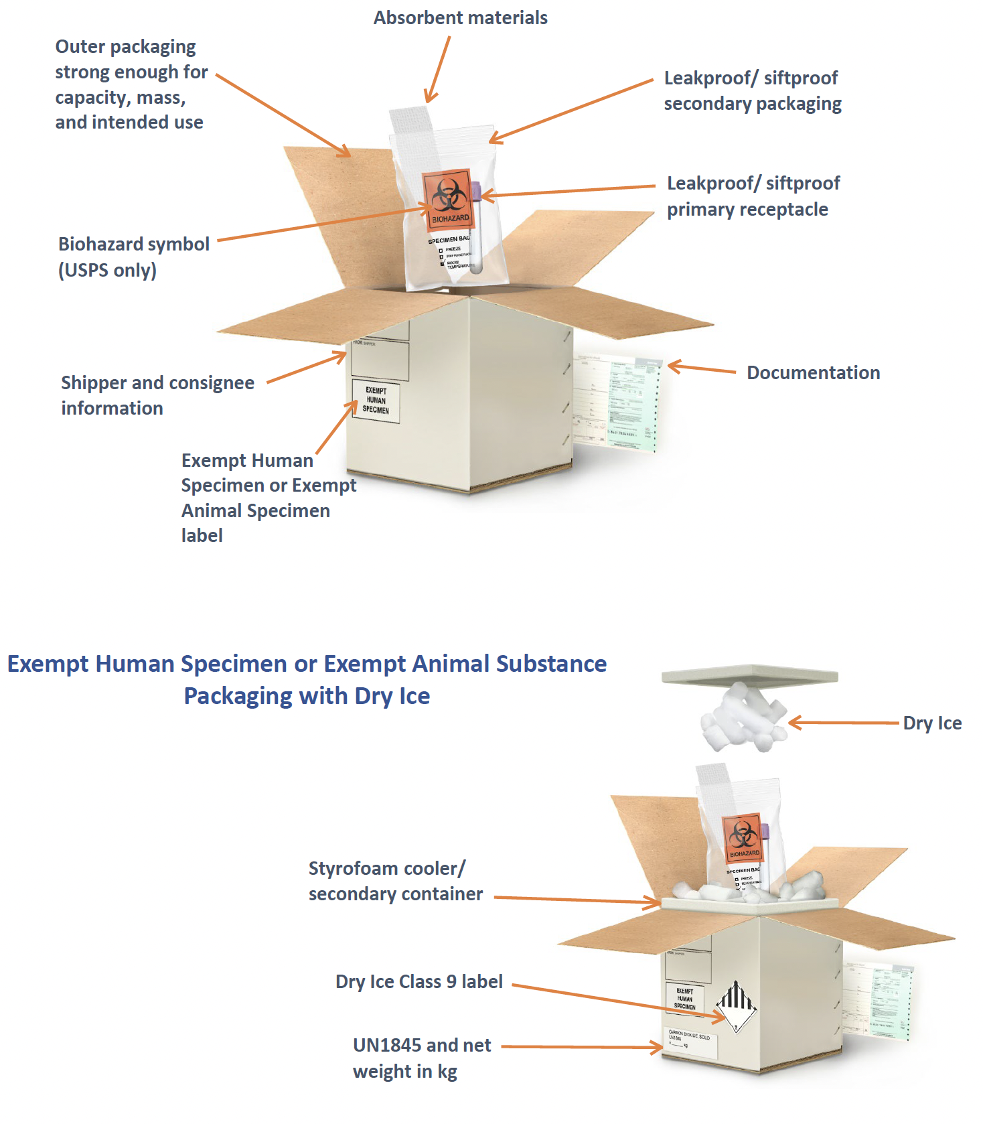

This job aid is a component of the free, on-demand CDC training course “Packing and Shipping Dangerous Goods: What the Laboratory Staff Must Know.” Find the course at https://reach.cdc.gov/training. v.23032

