Sections of the Microscope

Introduction

Microscopy has a very important role in microbiology laboratories. A microscope is an essential tool for viewing microorganisms that are too small to be seen by the naked eye.

To use your microscope effectively and efficiently in your daily routine, it is necessary that you become familiar with the major sections of the microscope.

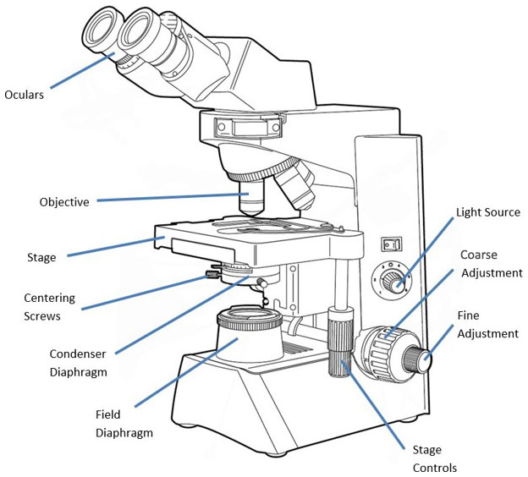

Functions of the Microscope Sections

Centering Screws — two screws attached to the condenser diaphragm used to center the light in Kohler illumination.

Coarse Adjustment Knob — used for rapid or rough positioning of the specimen at the focal point of the objective lens.

Condenser Diaphragm — the lens system beneath the microscope stage, positioned to concentrate light correctly on the specimen and direct the light rays into the objective. It is either a rotating disc or an iris diaphragm on the condenser used to direct the appropriate wide/slender illumination cone to the specimen and entering the objective.

Field Diaphragm — an iris diaphragm, usually located on the base of the microscope, that controls the amount of light that enters the condenser diaphragm.

Fine Adjustment Knob — exactly positions the specimen at the focal point of the objective lens.

Iris Diaphragm — An iris diaphragm is an adjustable opening made of thin metal leaves. It controls the amount of light that passes through.

Light Source — Usually located in the base of the microscope. It is responsible for shining light on the specimen on the slide.

Objectives — The lens system nearest the specimen used to magnify and direct image-forming rays of the specimen to the oculars, where they are further directed and magnified. Objectives are most important for determining the quality of the image produced.

Oculars — Magnifying lens system of the microscope nearest to the eyes. Further enlarges the image produced by the objective.

Stage Controls — Controls under the stage of a microscope that move the stage back and forth for examination of a specimen slide.

