Procedural Steps for Identifying and Prioritizing Essential Functions

Step 1: Identifying Essential Functions - Categorization
To identify the essential functions, it is initially helpful to group all of the laboratory’s analytical and support functions into overarching categories. Depending on the particular laboratory’s operation, these broad categories may include (but are not limited to) the following:

- Biological or Chemical Threat/Terrorism
- Infectious Disease
- Environmental Health
- Newborn Screening
- Food Safety
- Laboratory Support

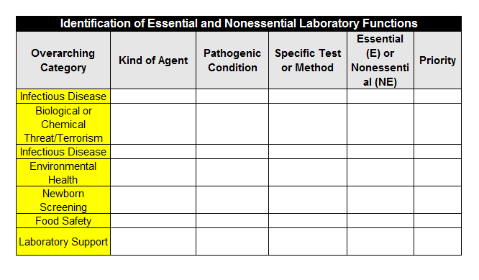

Step 2: Identify Essential Functions – Subdivision of Categories
The next step in identifying core laboratory activities is to create subdivisions within the overarching categories. These subdivisions are used to group the laboratory’s functions into those that are essential, and therefore must be continued, and those that are nonessential, which may be suspended. The nature of these subdivisions, or whether they are even necessary, depends upon the particular overarching category. For example, if all of the laboratory activities in the newborn screening category are considered essential, then subdividing this overarching category into smaller units to reveal essential and nonessential activities is unnecessary. The same may be true for an overarching category like environmental health. If all the routine testing of environmental samples is essential but readily outsourced to laboratories with comparable analytical capabilities and capacities in the private sector, then subdivision of this broad category may be helpful only to determine which alternate laboratory to use for particular kinds of analytical methods. In contrast, within a broad overarching category such as infectious disease, there may be both essential and nonessential activities that need to be identified. For example, while activities related to the subtyping of microbial isolates for early detection of infectious disease outbreaks may be essential to public health, some of the routine reference testing done in the public health laboratory may be nonessential. By effectively subdividing an overarching category like infectious disease, the process of differentiating between essential and nonessential activities becomes more manageable.

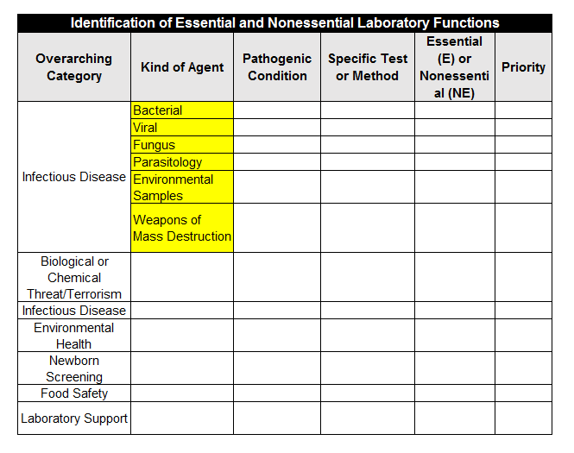

Identify and Prioritize Essential Functions
The overarching category of infectious disease can be examined as a model to identify and prioritize the essential functions of the laboratory. While other approaches or variations of this approach can be used, the outcome should be the same. The laboratory’s essential functions should become clearly identified and appropriately prioritized to guide COOP action.

For the purpose of this course, we will further breakdown the infectious disease category into various subdivisions. However, this procedure should be completed for all categories, as applicable, using subdivisions that apply to that category. The subdivisions may include the kind of microbial agent, the type of analytical tests or the nature of the laboratory program, i.e., enteric diseases, sexually transmitted diseases or invasive diseases. Other subdivisions may also be used. For this table, we will be subdividing the infectious disease agents using the following guide:
- First, divide each kind of agent into specific pathogenic conditions;
- Second, divide each condition into specific tests or general methods;
- Third, evaluate the activities listed to identify essential and nonessential; and
- Fourth, prioritize each essential function

Step 3: Divide Kind of Agent into Pathogenic Condition
In this step, you will want to divide the kind of agents you work with into specific pathogenic conditions.

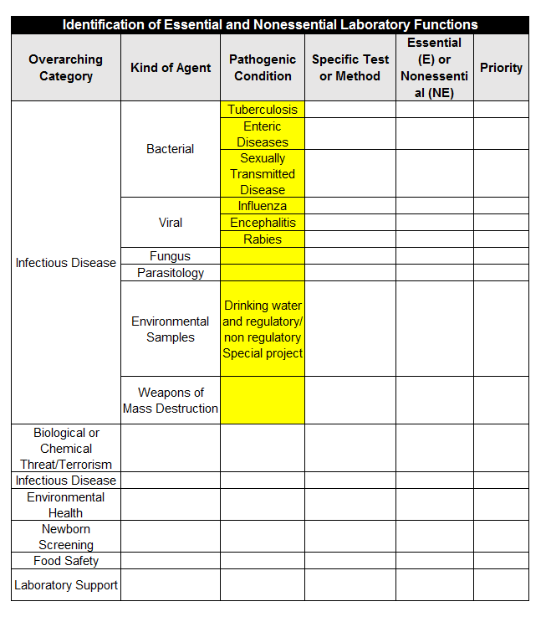

Step 4: Divide Pathogenic Condition into Specific Tests or Methods
In this step, you will want to divide the pathogenic conditions you work with into specific test or methods you use.

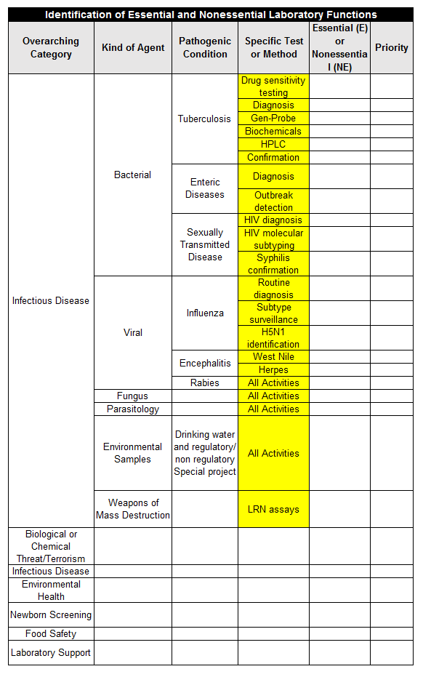

Step 5: Essential and Non-Essential
Some things to consider when identifying essential functions are:
- Laboratories should review their functions to determine those directed by applicable laws, directives, and executive orders.
- Laboratories should determine the essential functions that need to be continued uninterrupted or resumed within 12 hours, regardless of circumstance.
- Laboratories should identify those essential functions that provide interdependent support to an essential function performed by another organization, including when and where the vital support would be provided.

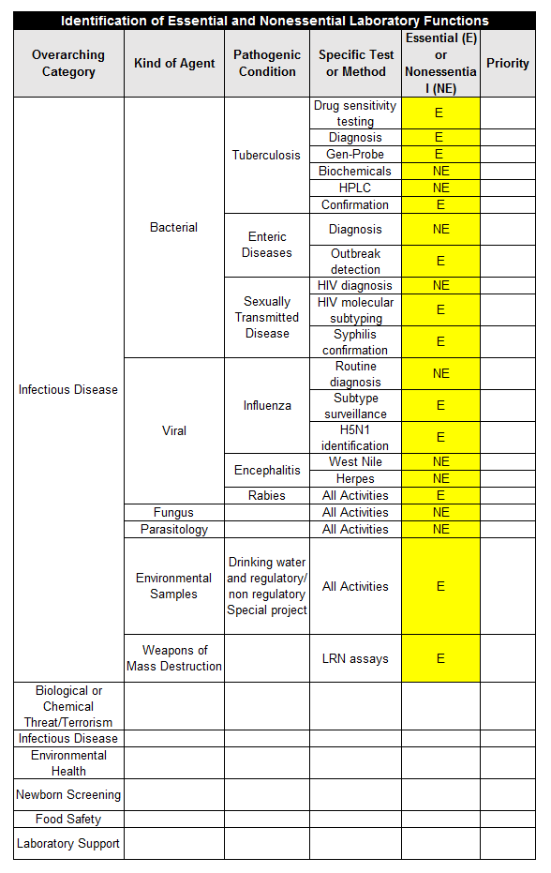

Step 6: Prioritize Essential Functions
Once the laboratory’s essential functions have been identified, they must be prioritized. Depending on the nature of the incident causing a disruption of the affected laboratory’s operation, it is possible that only some of the essential functions can be continued. It is therefore critical to know which have the highest priority. This prioritization should be based on time sensitivity and the public health impact if the function is NOT continued during the disruptive event. Each essential laboratory function should be rated as follows:

- Priority 1 – Highest priority
If the task, service or function is mission priority critical—life, health or safety issue if not restored within one hour.
Recovery/restoration objective: 0 to 12 hours, normally performed on a 24/7 basis

- Priority 2 – Medium priority
If the task, service or function is mission priority urgent —will cause definite, irreparable harm if not restored in less than 24 hours.
Recovery/restoration objective: 12 hour to 48 hours—normally performed on a 24/7 basis

- Priority 3 – Medium priority
If the task, service or function is a business unit priority — will cause definite irreparable harm if not restored in less than one week.
Recovery/restoration objective: two to seven days —a function that is routinely monitored on a daily basis

- Priority 4 –Lower priority
If the task, service or function is important — significant, but not time critical—normal day-to-day functions that would NOT cause irreparable harm if not restored within the first 30 days.
Recovery/restoration objective: from 1 week plus
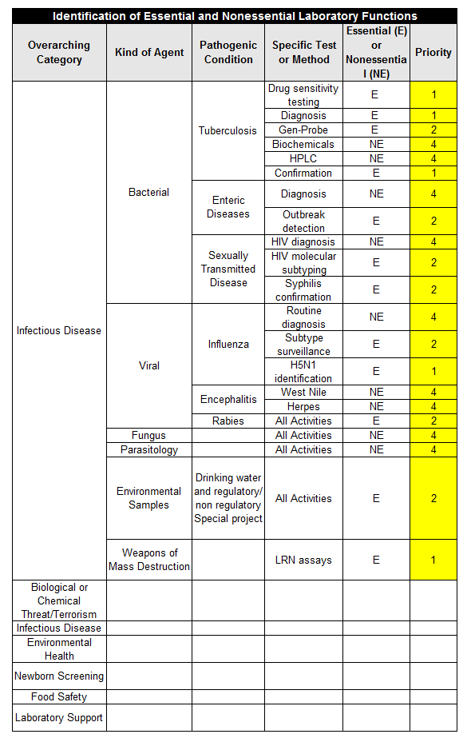
This job aid is a component of the free, on-demand CDC training course “Laboratory Continuity of Operations.” Find the course at https://www.cdc.gov/labtraining.

