[Insert your agency information here.]

Preparing a Wet Mount

Introduction
The Wet Mount is a procedure performed in the laboratory to observe motile organisms. It is commonly used to examine material collected from the vaginal wall of a female patient.

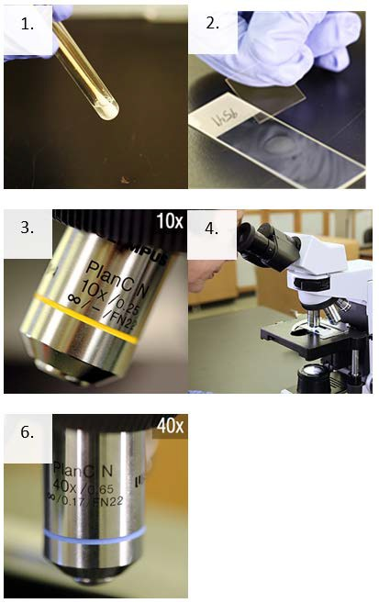
Supplies
- Personal protective equipment
- Sharps container
- Biological waste container and bag
- Sterile microscope slides
- Sterile pipettes
- Glass coverslips
- Pencil

Instructions
- Using a sterile dropper, gently mix and remove some of the specimen from the tube and place one drop (10µL) on a clean microscope slide with the patient’s identification number/name.
- Immediately put a coverslip over the sample for examination. A microscopic review of the slide should be performed as soon as possible to confirm the presence or absence of Trichomonads.
- Focus with low power (10X), low light.
- Scan the entire slide.
- Read at least 10 fields.
- Identify objects with high power (40X).
- Record results based on your laboratory’s criteria.
This job aid is a component of the free, on-demand CDC training course “Routine Microscopy Procedures.” Find the course at https://reach.cdc.gov/.
v24087

