Laboratory Test Request Example Job Aid

An example laboratory test request is below:

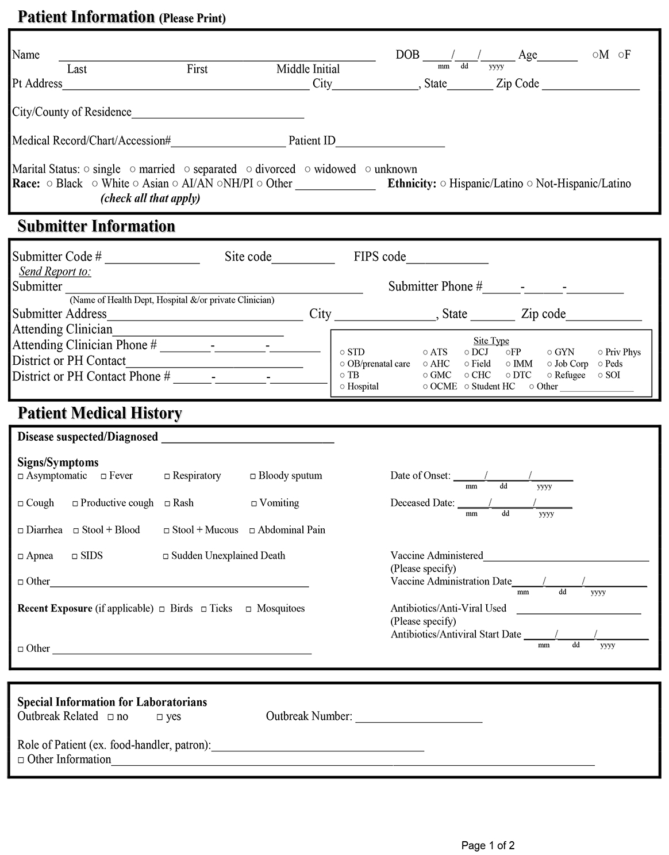

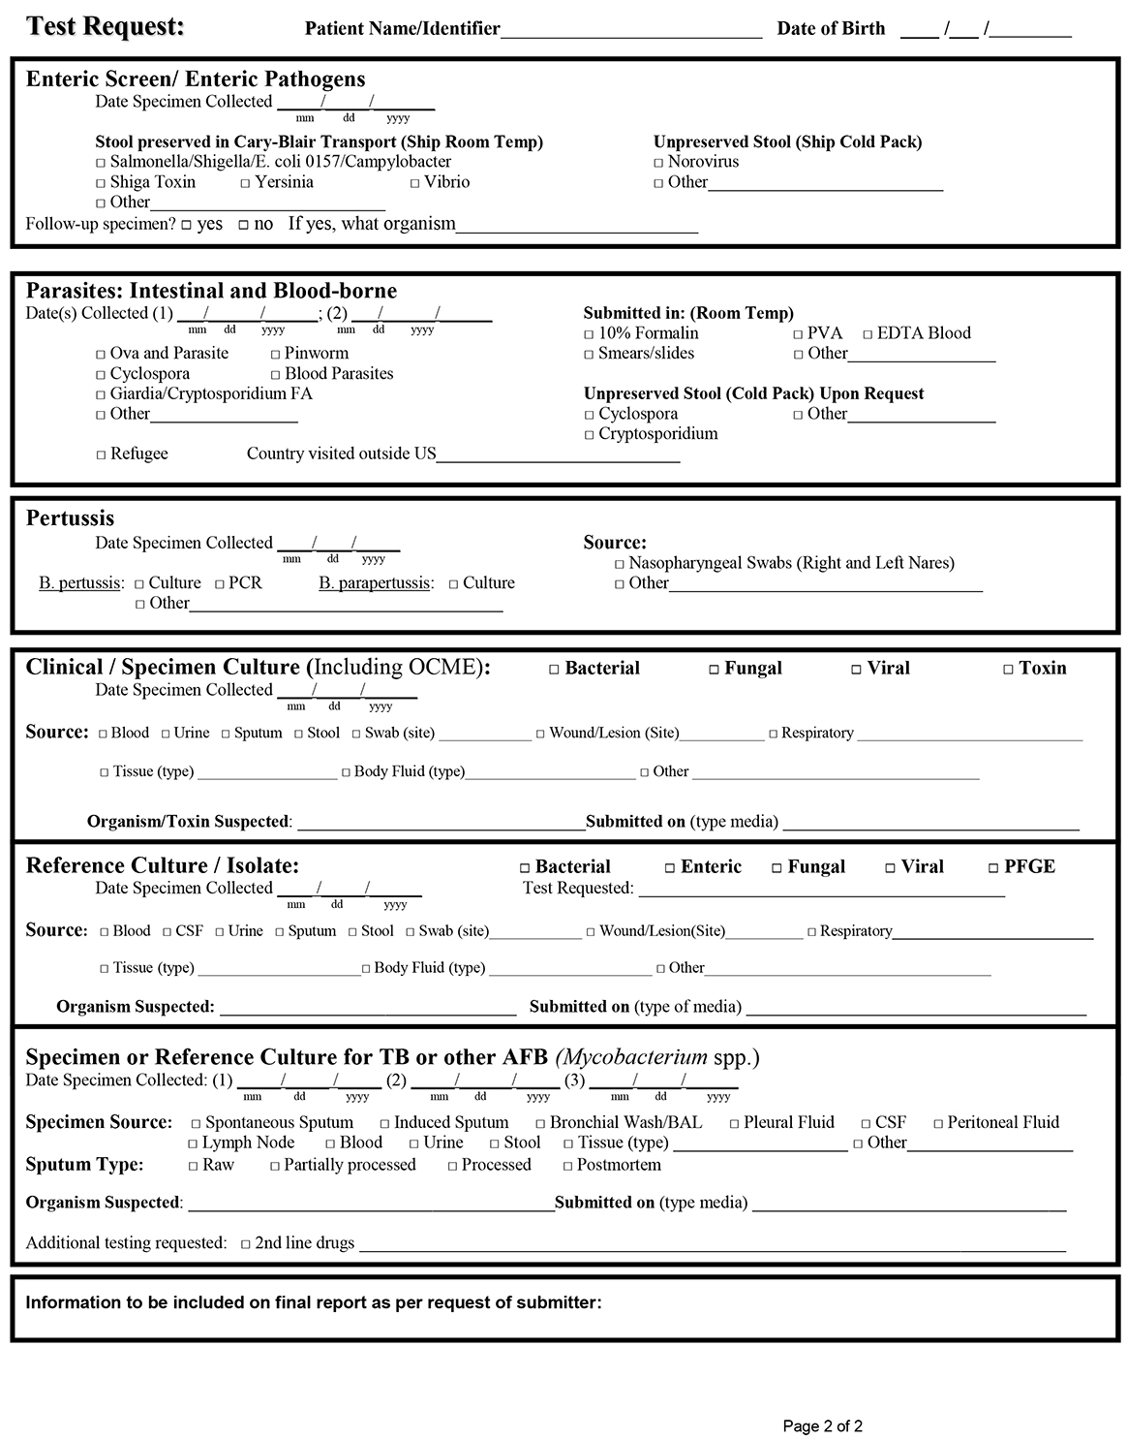

This job aid is a component of the free, on-demand CDC training course “Packing and Shipping Dangerous Goods: What the Laboratory Staff Must Know.” Find the course at https://reach.cdc.gov/training.

v.23032

