Laboratory Communications Toolkit
A Resource to Create
Meaningful Messages

Table of Contents
Introduction...................….………………………………………………………………….……….3

Clear Communication - Tools of the Trade...................….……………………………….….……..4

Laboratory Communication Planner Templates…………………...…………….……………....8

Know Your Target Audience……………………….……………….……………...........................9

Plain Language Tips……………………….…………………….……………….…......…….…....10

Design Feature Examples………………....…………………….……………….…….……..…....14

Plain Language Checklist……………...….…………………….……………….…….….….…....18

Laboratory Communications Resources……………….…..…………………….………….…....19

2

Introduction

Communicating complex laboratory information to various audiences, including individuals who may not have a laboratory background, is challenging.

Clinical and public health laboratories can use this toolkit to translate complex information into user-friendly messages for various audiences. The toolkit contains information on health communication tools and plain language tips, as well as a Laboratory Communications Planner Template, Plain Language Checklist, and additional resources to optimize communication with your target audience.

This toolkit is based on the OneLab Webinar “Principles in Plain Language: Communication for Laboratory Professionals” and reviews principles, tools, and resources commonly used to develop plain language communications for various audiences. Review your laboratory's communication policies and procedures for site-specific requirements.
3

This list of tools and guided questions will help you create communication products that translate complex technical information into meaningful messages for your audience.

Clear Communication - Tools of the Trade

Define your Audience

Who are you talking to?
Identify the audience and its needs to increase the effectiveness of your
message. Use these questions to think more about your primary audience:
- Who is the audience? Be specific.
Example: individuals who will be receiving their own test results
- What is the primary goal of communication? What does the audience need to know to reach the desired goal?
Example: to provide a contact number for testing inquiries
- How should your audience feel after reading your material?
Example: clear on the next steps and empowered to take action

Craft your Content

What is the call to action or main message? What does the audience need to know or do?

Begin your message with the most important information – the call to action is the main takeaway for your audience.
Include a clear call to action. Identify who the message is for, state what they need to do, and provide relevant details – for example, when, where, why, and how to do it.
This should be no more than 1-3 sentences
Example: If you have questions after receiving your test results, call 000-000-0000. Assistance is available at this number M-F from 8 AM-8 PM EST.

4

4. Determine your Communication Channel

What is plain language?

Plain language is communication your audience can understand the first time they read or hear it. It is clear, concise, well organized, and follows other best practices appropriate to the subject or field and intended audience. The top three plain language recommendations are to avoid technical jargon, spell out acronyms, and organize information into chunks. The Plain Language Tips in the next section provide more detail about this.

3. Use Plain Language

How does your audience prefer to receive information? Where will they use the information?

Determine the channel (for example, social media, email, a website, or a PowerPoint presentation) that your audience prefers to receive a particular kind of information or content. Then format your content to ensure it is appropriate for that channel and conveys the information effectively.
What message do you convey with your images?
Use stock photo libraries to find images to use in your materials. The CDC Public Health Image Library (PHIL) found at https://phil.cdc.gov/ is a free resource that contains photos and illustrations to add to your message.

5. Images and Words
Review images and words to confirm they are appropriate for the audience. Images should help clarify abstract written concepts. Images can include photos (stock and custom), graphics, 2D/3D illustrations, and GIFs (animations or motion graphics). It is essential to confirm the images are relevant to your topic and are at a high enough resolution to avoid any image distortion.

5

How do you communicate the right message to the right person at the right time during an emergency?

6. Crisis and Emergency Risk Communication (CERC)

CDC's Crisis and Emergency Risk Communication (CERC) program provides training, tools, and resources to help health communicators, emergency
responders, and leaders of organizations communicate effectively during emergencies. This is an excellent resource for new and seasoned
communicators alike. For more information on CERC, visit www.emergency.cdc.gov/cerc.

8. Apply a Customer Service Approach

How can you streamline responses to questions?
Prepared responses are an efficient way to address frequently asked questions. Pre-craft and pre-clear questions and answers in advance, then refine that content as needed. Review responses regularly (e.g., weekly, monthly, quarterly, or as guidance changes) to ensure the information remains accurate and timely.

7. Look for Ways to Introduce Efficiency when Responding to Inquiries

How do you build a relationship with patients and partners?
Applying a customer service approach to communications helps build and maintain rapport.
Remember to
    - Respond in a timely manner
    - Use a professional tone
    - Maintain transparency
    - Have additional references or sources available to share for more information
6

Summary

Does CDC offer resources to help craft user-friendly messages?

Yes! Check out the Resources section of this guide.

9. Resources

Use these simple, actionable recommendations to develop a strategy for meaningful, user-friendly communication with your target audience.

Review the Principles in Plain Language: Communication for Laboratory Professionals presentation for more information.

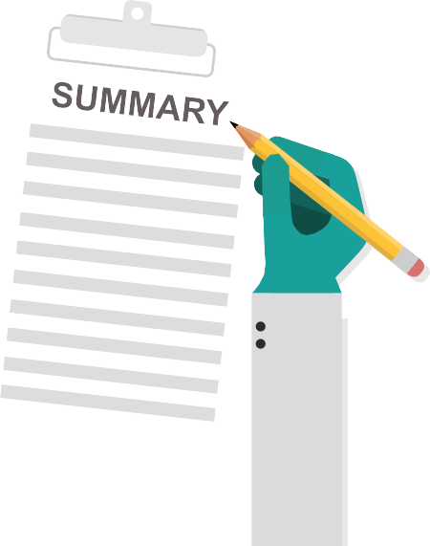

Laboratory Communication Planner Template

7

Laboratory Communication Planner Template

Laboratory XXX
Name of Project Lead

Use the template below to create new communication products for various audiences.
8
Approval Route
Start Date
Product Title
8
Expected Release Date
Additional Resources
Who needs to approve this message before sending to the desired audience? (e.g., supervisor, manager, laboratory director, etc.)

When will you share the communication? Is there a new policy, procedure, guideline, or requirement that will aﬀect when the audience receives this message?

What resources (for example, animations, graphics, tables) can you use to help convey the message to your audience and achieve the desired result?

What graphics would help your audience better understand the message?
Key Graphics
Format

Distribution
Preference
Which communication channels do your target audience prefer? How do they typically use these channels? For example, will this be shared as a printed document by mail, a virtual document by email, communicated over the phone, using social media, or shared on the laboratory's website?

Print ☐ Electronic ☐

In-Person ☐ Mail ☐ Email ☐ Presentation ☐

Social Media ☐ Over the Phone ☐ Organization Website ☐

What does the audience need to know or do?
Who will use this product or perform the desired action?
What is the desired result?
Communication Channel
Main Message
Communication Goal
Target Audience
Project Approved By

Here are some additional questions and other considerations that can help you tailor your message to your target audience and address their needs.

Know Your Target Audience

- Could any of them have limited reading skills or difficulty reading or speaking English?
- Could any of them have limited technical/scientific knowledge or low
health literacy?
- What else might make it hard for them to process or understand your message?

2. Identify the purpose of your message.
What questions and concerns might your audience have about the topic?
What are some things that could affect their ability to process your messages?

1. Get to know your target audience.

Identify just one purpose. For example, your purpose might be one of the following:
- To motivate your audience to get tested for .
- To help them understand the testing process of _______________________.
- To help them understand test results: positive, negative,
and inconclusive.

What do you want your audience to think, feel, or do after hearing or reading your message?
- Examples: Think about getting tested for .
Feel less afraid to get tested.
Get tested.

What might motivate them to do what you want them to do?
What might discourage them?

In 1-3 sentences, describe the most important thing you want your audience to remember after they hear or read your message.
9

Use common, everyday words (avoid technical jargon)

Plain Language Tips

Use plain language so that your audience understands the message the first time they hear or see it.

Plain language is helpful because it
- Encourages adoption of new behaviors
- Decreases misinterpretation of information

In this section, we share plain language principles and provide examples of each one.

It's important to use language your audience understands. Use common, everyday words to make your message clear.
Before:
Based on the information we have to date, the incubation period for Middle East Respiratory Syndrome (MERS) — the time between when a person is exposed to MERS and when they start to have symptoms — is 2-14 days.

After:
After the virus that causes Middle East Respiratory Syndrome (MERS) enters a person's body, it takes 2 to 14 days for that person to show the first signs of being sick, based on what we currently know so far about the disease.
10

Define acronyms

Limit the use of acronyms in your writing and instead spell the words out if they will only be used once. If you must use acronyms, define them.

Before:
POC testing involves performing a diagnostic test at or near the point of care, often away from a laboratory. POC tests can produce rapid and reliable results to aid in identifying or managing chronic diseases and acute infections.

After:
Point-of-care (POC) testing involves performing a diagnostic test at or near the point of care, often away from a laboratory. POC tests can produce rapid and reliable results to help identify or manage chronic diseases and acute infections.

Use logical organization

The information in the message needs to follow a clear flow or process. If you are communicating about a series of steps, present them in order.
Before:
If your hands have been exposed to blood or body fluids, rinse hands thoroughly and dry with disposable towels, wet hands with warm running water, use a disposable towel to turn off the faucet, and apply soap and water liberally and vigorously scrub all surfaces of hands and fingers.

After:
If your hands have been exposed to blood or body fluids:
- Wet hands with warm running water.
- Apply soap and water liberally and vigorously scrub all surfaces of hands and fingers.
- Rinse hands thoroughly and dry with disposable towels.
- Use a disposable towel to turn off the faucet.
11

Use short sentences to improve message clarity and reduce the possibility of overwhelming the reader with too much information.

Use short sentences

Before:
It is important for healthcare providers and testing personnel to understand the performance characteristics, including sensitivity, specificity, and positive and negative predictive values, of the antigen test being used, and to follow the manufacturer's instructions for use, which summarize performance characteristics.

After:
It is important for healthcare providers and testing personnel to understand the performance characteristics of the antigen test they are using. Examples of performance characteristics include sensitivity, specificity, and positive and negative predictive values. Providers and testing personnel should follow the manufacturer's instructions for use, which summarize these performance characteristics.
12
After:
We used a system to monitor the function of sensitive proteins.
A noun string — using several nouns in a row — can make information difficult for the reader to interpret. Reword sentences with noun strings to create a clear message your reader can easily interpret.

Before:
We used a sensitive protein function monitoring system.

Avoid noun strings

Avoid hidden verbs
After:
These are general batch testing tips for various COVID-19 tests.
Before:
These are general batch testing tips on various COVID-19 tests.
A preposition is a word that modifies a noun, adjective, or verb. Prepositions often express a relationship in time or space. In, on, to, of, since, and by are examples of common prepositions. Choose the correct prepositions to help ensure you communicate the right message.

Check prepositions

Hidden verbs are actions turned into nouns. Hidden verbs make sentences longer than necessary and make information difficult to interpret.

Before:
We must undertake the calculation of new figures for the laboratory report.

After:
We must calculate new figures for the laboratory report
13
After:
A laboratory technician inadvertently contaminated the specimen.
Before:
The specimen was contaminated.
Sentences written using passive voice might leave readers wondering who performed the action.
Use active voice, where the subject of the sentence does something.

Use active voice

Instead of using long blocks of text in your writing, use easy to read design features such as:

Use easy to read design features
- Headings
- Short paragraphs (chunking) and white space
- Tables
- Bulleted lists using a parallel structure (see the Design Feature Examples section below for a definition)

The following section will provide examples of how each design feature can create clear messages for your audience.

Headings organize information and communicate the main subject of your text. Both headings and sub-headings help readers identify what topic(s) are contained within the content. In the example below, the heading helps the reader identify that the included information is related to certification statements.

1. Headings

Below are some examples of design features that help emphasize and clarify the intended message for your audience.

Design Feature Examples

Example:
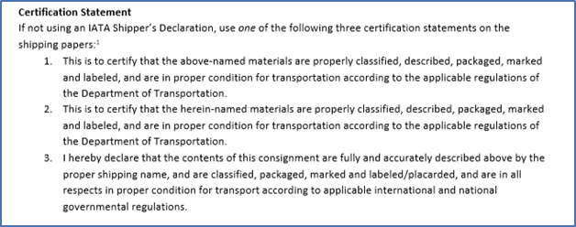
14

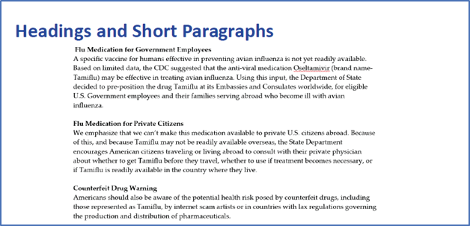
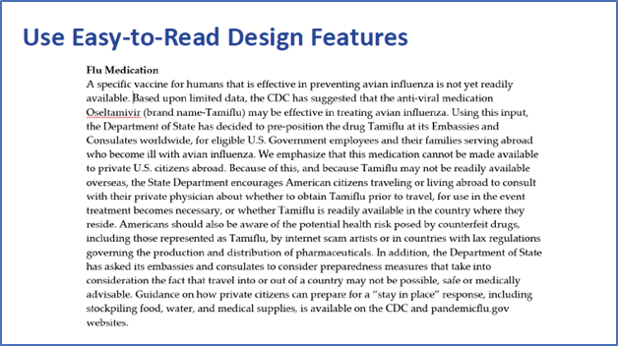

2. Short paragraphs (chunking) and white space

Divide text into short paragraphs. Too much text creates a "wall of words" that is hard to read. Long sections with no white space make your content hard to understand.

Before:
The paragraph below contains too many sentences and is hard to read. There is no white space or sub-headings to separate the topics.

After:
15
To make this easier for the reader to understand, divide this text into short paragraphs and add sub-headings. The white space between each paragraph also makes the text easier to rea

Use tables when you have a lot of comparisons or if-then statements.
3.
Tables

Before:
Because colds and flu share many symptoms, it can be difficult (or even impossible) to tell the difference between them based on symptoms alone. Special tests can tell if a person is sick with flu. You should look out for signs and symptoms to determine if you have a cold or the flu. The symptoms of flu can include fever or feeling feverish/chills, cough, sore throat, runny or stuffy nose, muscle or body aches, headaches, and fatigue (tiredness). Cold symptoms are usually milder than the symptoms of flu and typically do not include fever. People with colds are more likely to have a runny or stuffy nose. Colds generally do not result in serious health problems.

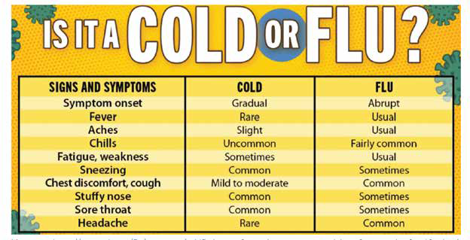
After:

Graphic can be found at: https://www.cdc.gov/flu/symptoms/coldflu.htm.

When using a bulleted list, provide a lead-in sentence first. Use parallel construction to develop the list. Parallel construction means every item in the list should start with the same part of speech, and the lead in-sentence should form a complete sentence when read with each item in the bulleted list.

Bulleted lists using a parallel structure
4.

16
16

After:
Those at higher risk for severe illness include:
- People who are age 65 or older
- People who have severe underlying medical conditions
- People who are immunocompromised
Before:
Those at higher risk for severe illness include:
- Elderly
- People who have severe underlying medical conditions
- If you are immunocompromised
Bulleted lists using a parallel structure continued
4.

Summary

The words and formats you choose can influence whether your messages are user-friendly. Apply these plain language principles to help your audience understand your message the first time.

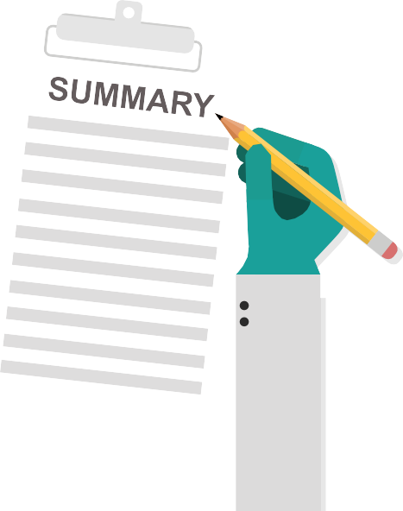

17

Plain Language Checklist

Use this checklist to develop messages your audience can understand the first time.

- Use common, everyday words
- Define acronyms
- Organize content based on a process or logical flow
- Streamline information into short, clear sentences
- Avoid noun strings
- Use appropriate prepositions
- Avoid hidden verbs
- Use active voice
- Chunk information by subject matter or topic
- Use relevant headings and sub-headings
- Use white space, tables, bullets, and/or numbered lists as needed
18
18

Principles in Plain Language: Communication for Laboratory Professionals

Health Communication

Laboratory Communications Resources
Presentation designed to equip laboratory professional with information to build their own communication toolkits.
https://www.cdc.gov/labtraining/onelab/docs/8.26.2021_OneLab-Network-Event_Slides.pdf

Example Materials
Before and after examples of materials scored and updated using the Clear Communication Index.
https://www.cdc.gov/ccindex/examplematerial/index.html

The CDC Clear Communication Index
The CDC Clear Communication Index website contains tools and other resources to help you develop and assess public communication materials.
https://www.cdc.gov/ccindex/index.html

Gateway to Health Communication
This is a one-stop shop for health communicators. https://www.cdc.gov/healthcommunication/index.html

Health Literacy
This site is for health communicators, public health professionals, and community
leaders who seek information and tools on health literacy research, practice, and evaluation. www.cdc.gov/healthliteracy

Crisis and Emergency Risk Communication (CERC)
CDC's Crisis and Emergency Risk Communication (CERC) provides training, tools, and
resources from lessons learned during past public health emergencies and research in the fields of public health, psychology, and emergency risk communication.
https://emergency.cdc.gov/cerc/index.asp

CDC Public Health Image Library {PHIL)
The website contains a search engine for photos related to public health. https://phil.cdc.gov/
19

Everyday Words for Public Health Communication

Plain Language

Laboratory Communications Resources Continued
A thesaurus for public health terms. https://www.cdc.gov/healthcommunication/everydaywords/index.html

Plain Language Medical Dictionary
A plain language dictionary created by the University of Michigan. https://apps.lib.umich.edu/medical-dictionary/

Simply Put
A guide for creating easy-to-understand materials. https://www.cdc.gov/healthliteracy/pdf/simply_put.pdf
20

v.23032

