Creating a Secondary Container Label

Most laboratories have established a protocol for labeling secondary laboratory containers in their Chemical Hygiene Plan. This protocol combines OSHA HazCom Standard requirements and CLIA requirements.
Method XYZ
Stock Solution:
Methanol 30%
Water 65%
Acetic Acid 5%
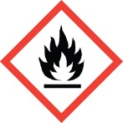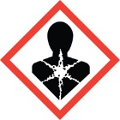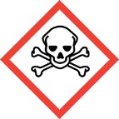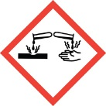
Store at 10⁰C

Date Prepared: 10/4/13
Initials: ALR
Expiration Date: 12/7/14
A laboratory-compliant secondary chemical container label will have the following information:
- Identity of the contents and concentration (titer and strength if applicable)
- Hazard(s) of each chemical (this can be expressed using pictograms or text) – obtain from Section 2 of each chemical’s SDS
- Date of preparation
- Initials of preparer
- Date of expiration
- Storage requirement (if other than room temperature)
Method XYZ
Stock Solution:
Methanol 30%
Water 65%
Acetic Acid 5%
Hazards:
Highly Flammable
Toxic if swallowed, in contact with skin or if inhaled
Causes damage to organs
Causes severe skin burns and eye damage
Causes serious eye damage

Store at 10⁰C

Date Prepared: 10/4/13
Initials: ALR
Expiration Date: 12/7/14

Note: you do not have to include the hazards of
chemicals that are less than 1% of the mixture.
The exception is for carcinogens, you must list
that hazard if the chemical carcinogen’s concentration
is 0.1% or greater.

Laboratory Training Branch

Center for Surveillance, Epidemiology, and Laboratory Services

