Hand Hygiene Job Aid

When you wear disposable gloves, you must still clean your hands for proper hygiene. When performing testing, you should change gloves after each patient. You should also wash your hands or clean them with alcohol-based sanitizers after each patient.

There are two ways to clean your hands for proper hygiene: washing with water and using alcohol-based sanitizer.

Hand Washing Steps
If a hand washing sink is available, follow the steps below:

- Wet your hands with warm running water.
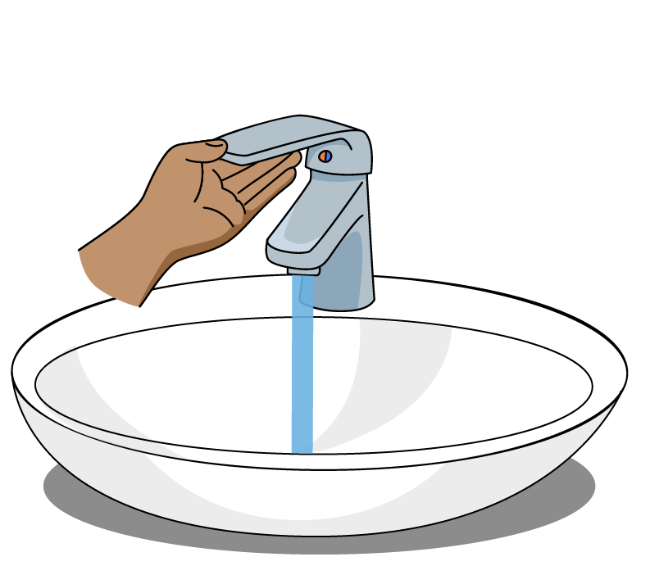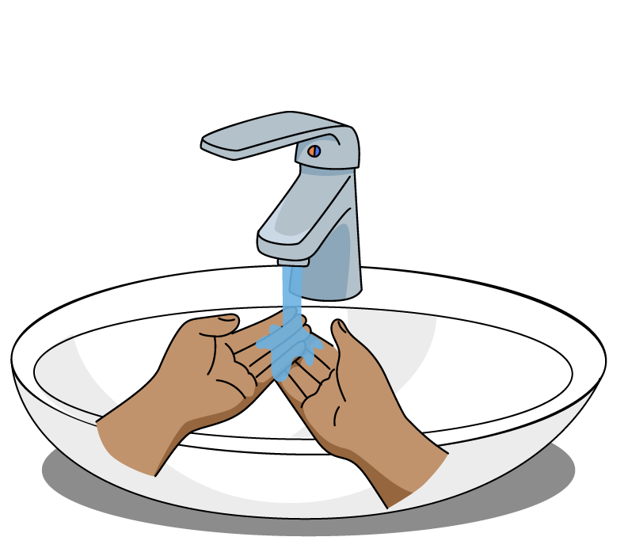
- Apply the soap and spread it to all surfaces of your hands and fingers. Rub your hands together for at least 20 seconds.
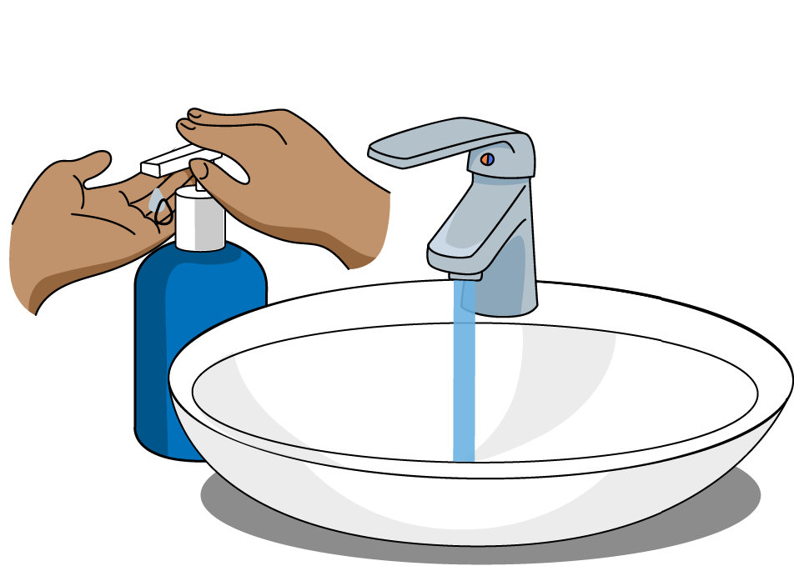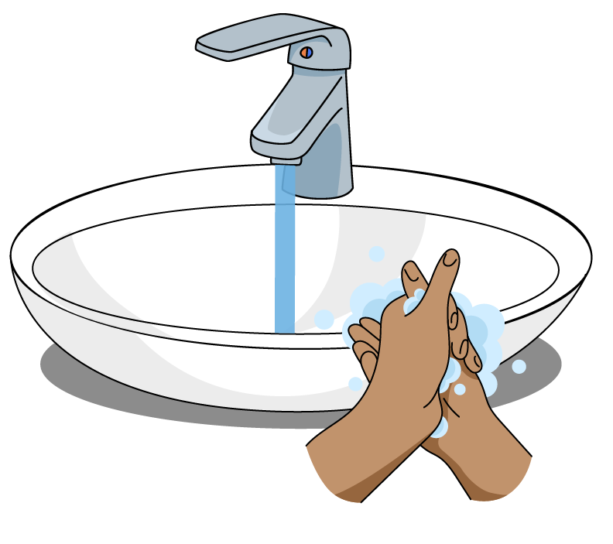
- Rinse your hands thoroughly and dry them with disposable towels.
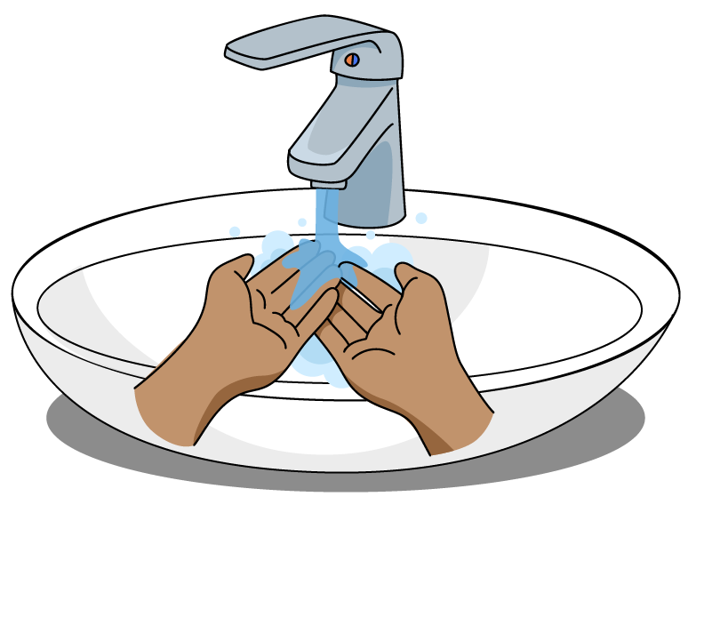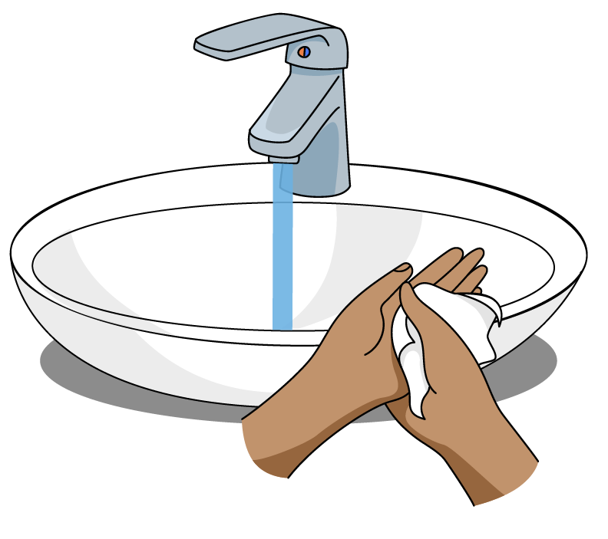
- Use a disposable towel to turn off the faucet. Discard towels in the regular trash.
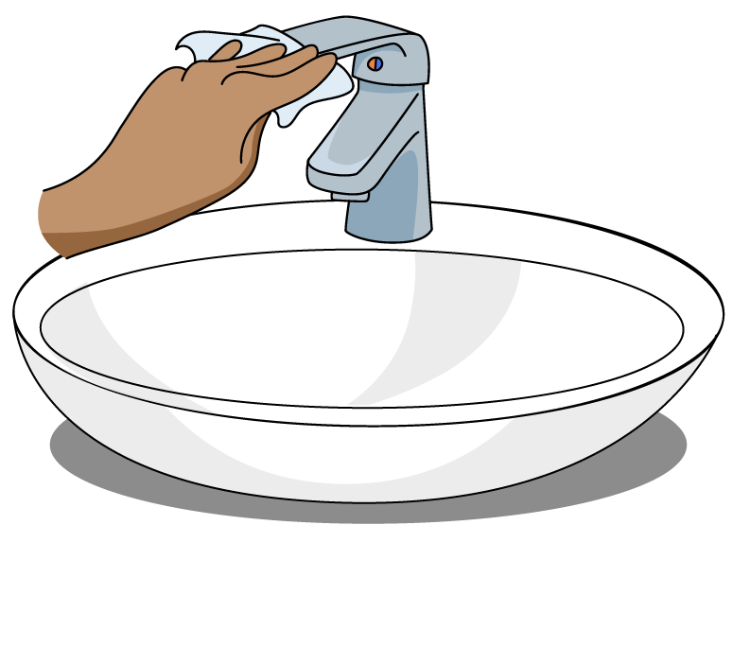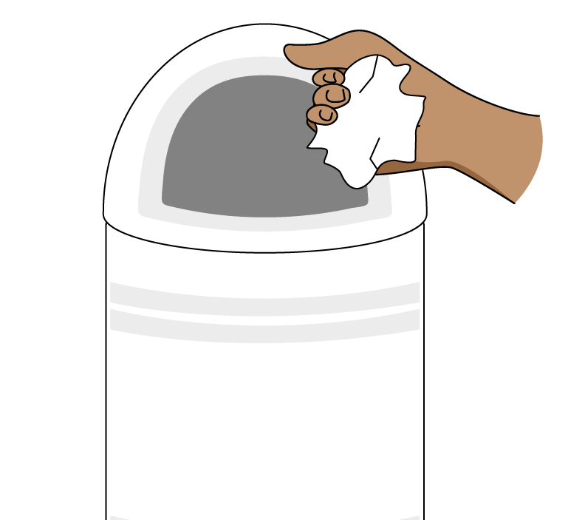

Hand Sanitizing Steps
If a hand washing sink is not available, follow these steps:

- Find an alcohol-based hand sanitizer. The alcohol content should be at least 60 percent.
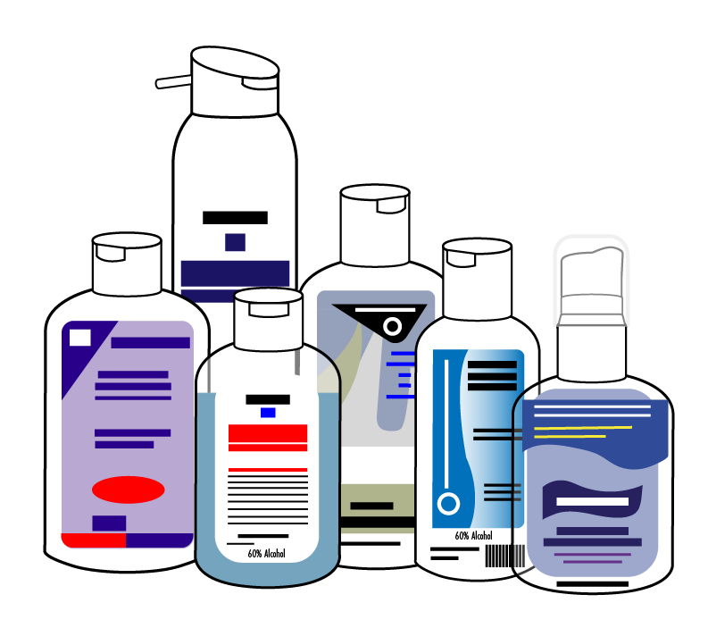
- Read the manufacturer’s instructions to see how much hand sanitizer to use.
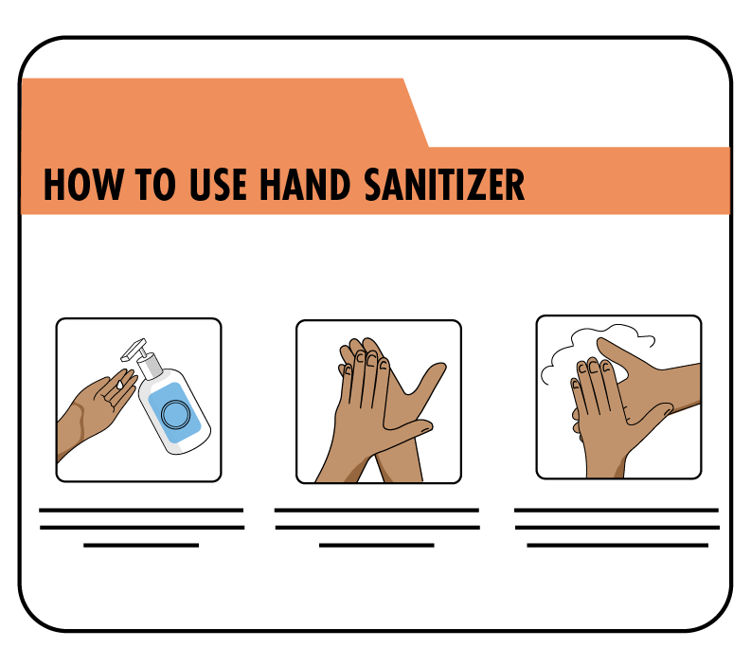
- Apply the sanitizer to one palm. Rub your hands together to cover all surfaces of your hands and fingers. Stop when hands are dry.
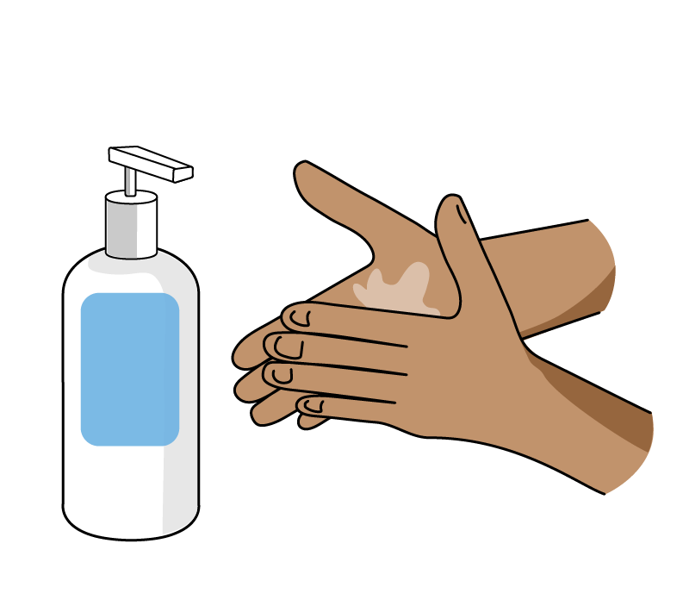
- Wash your hands with soap and water as soon as possible.
