Glove Removal Job Aid

Disposable Gloves (latex, vinyl, nitrile)
Disposable gloves reduce hand contamination, prevent cross-contamination, and protect from infection. Gloves should fit properly; not restrict hand coordination; accommodate individual requirements, such as allergy to latex, and meet the requirements of the task being performed. Rings, long fingernails, and fingernail jewelry can make it more difficult to put on gloves properly and can also cause gloves to tear more easily.
To help prevent allergic reactions to latex gloves:
- Do not use oil-based hand creams or lotions when wearing latex gloves.
- Wash your hands with a mild soap and dry thoroughly after removing gloves.
- Do not use powdered latex gloves.

For additional latex allergy information visit Latex Allergy: A Prevention Guide

Precautions:
- Cover open sores, dermatitis, cuts, and other lesions with a dressing or bandaging.
- Wash hands before putting on gloves.
- Never wash or reuse disposable gloves.
- Remove gloves after they become contaminated and before leaving the work area.
- Remove contaminated gloves using a procedure that avoids contact with the outer surface of the gloves.
- Dispose of contaminated gloves in infectious waste containers in the work area.
- Wash hands immediately, or as soon as possible after the removal of gloves.

Procedure for Removing Gloves Safely (Illustrations)
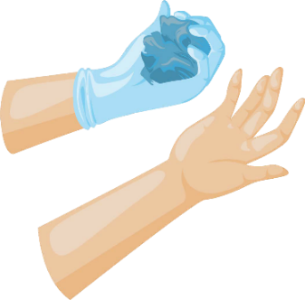
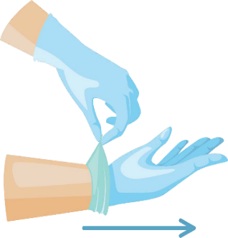
- Grasp the outside of one glove at the wrist. Do not touch your bare skin.
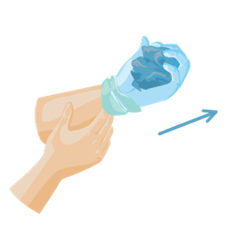
- Peel the glove away from your body, pulling it inside out.
- Hold the glove you just removed in your hand.

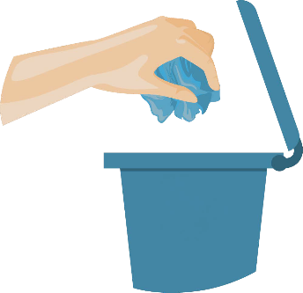
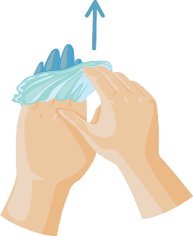

- Peel off the second glove by inserting two fingers under the glove at your wrist.
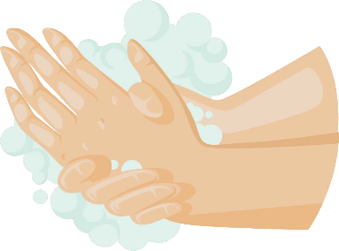
- Turn the second glove inside out while pulling it away from your body, leaving the first glove inside the second.
- Wash your hands immediately after removing your gloves.

- Discard the gloves in an infectious waste container. Do not reuse the gloves

This job aid is a component of the free, on-demand CDC training course “Ready? Set? Test!” Find the course at https://reach.cdc.gov/training.

