Blood and Body Fluid Exposure
It is important to use standard precautions when cleaning up blood or body fluids. Always assume they are contaminated, and act accordingly.

If your hands have been exposed to blood or body fluids, follow the steps below.
- Rinse the affected area with large amounts of water or saline solution for several minutes.
- Apply soap and water liberally and vigorously scrub all surfaces of hands and fingers.
- Rinse hands thoroughly and dry with disposable towels.
- Use a disposable towel to turn off the faucet.
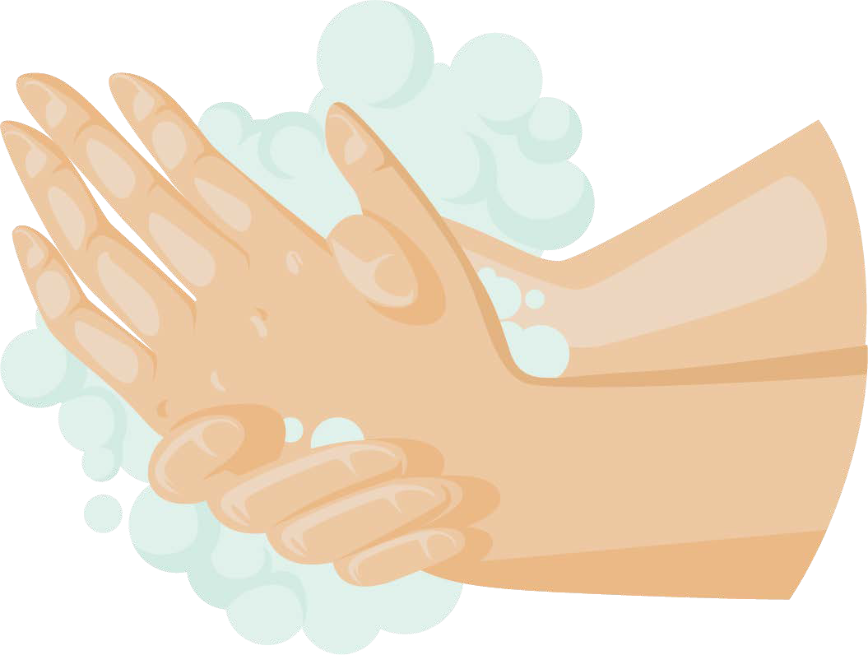
Important: Before leaving the area, decontaminate the sink and faucet handles. Use 10% bleach or an EPA-registered disinfectant that is effective against hepatitis B virus (HBV), HIV, and other bloodborne pathogens.

If your nose, mouth, or eyes have been exposed to blood or body fluids, follow the steps below.
- Rinse the affected area with large amounts of water or saline solution for several minutes.
- If running water is not available, use another source of water to rinse, such as bottled water.

If your skin has been punctured by a sharp instrument or needle, follow the steps below.
- Wash the puncture wound with soap and water. Encourage the puncture to bleed by gently squeezing it, if necessary.
- Bandage the puncture.

Report exposures.
- Report any exposures to those who are responsible for managing exposures. Report exposures promptly because treatment might need to start right away.
- Talk to the provider managing your exposure about the possible risks of acquiring HBV, HIV, and other bloodborne pathogens, as well as the need for post-exposure treatment.

